**All the plots should have labels, title,axis limits(ticks), legend and Inferences on the plot**

(Use the Company Sales Dataset)

1. Use the company sales data and plot the Total profit of all months.

import pandas as pd

import matplotlib.pyplot as plt

df = pd.read_csv("C:\\Users\\91778\\Desktop\\python ExcelR\\Assignments\\company_sales.csv")

profitList = df ['total_profit'].tolist()

monthList = df ['month_number'].tolist()

plt.plot(monthList, profitList, label = 'Month-wise Profit data of last year')

plt.xlabel('Month number')

plt.ylabel('Profit in dollar')

plt.xticks(monthList)

plt.title('Company profit per month')

plt.yticks([100000, 200000, 300000, 400000, 500000])

plt.legend(loc='upper left')

plt.show()

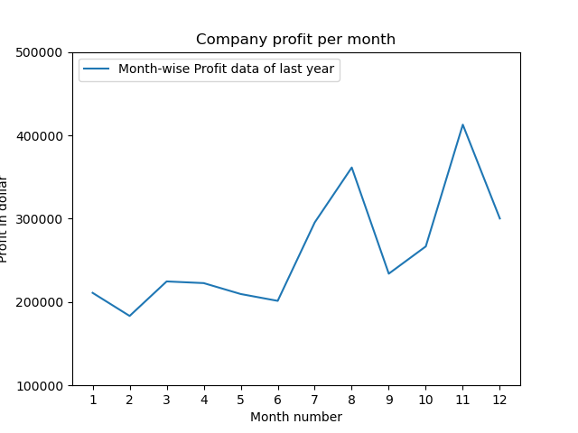

1. Read toothpaste sales data of each month and show it using a scatter plot.

Also, add a grid in the plot. gridline style should “–“.

import pandas as pd

import matplotlib.pyplot as plt

df = pd.read_csv("C:\\Users\\91778\\Desktop\\python ExcelR\\Assignments\\company_sales.csv")

monthList = df ['month_number'].tolist()

toothPasteSalesData = df ['toothpaste'].tolist()

plt.scatter(monthList, toothPasteSalesData, label = 'Tooth paste Sales data')

plt.xlabel('Month Number')

plt.ylabel('Number of units Sold')

plt.legend(loc='upper left')

plt.title(' Tooth paste Sales data')

plt.xticks(monthList)

plt.grid(True, linewidth= 1, linestyle="--")

plt.show()

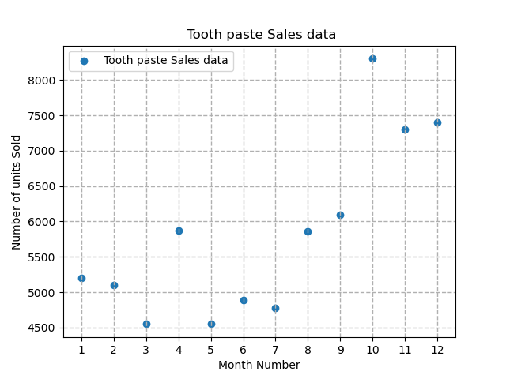

1. Plot the Total profit column with Boxplot(horizontal, Vertical, Notch), Histogram, barplot, Dotchart.

BARPLOT

import pandas as pd

import matplotlib.pyplot as plt

df = pd.read_csv("C:\\Users\\91778\\Desktop\\python ExcelR\\Assignments\\company_sales.csv")

monthList = df ['month_number'].tolist()

totalprofit =df['total_profit'].tolist()

plt.bar(monthList,totalprofit)

plt.xlabel('month number')

plt.ylabel('totalprofit')

plt.legend(loc='upper left')

plt.title('Total profit data')

plt.xticks(monthList)

plt.yticks([100000, 200000, 300000, 400000, 500000])

plt.show()

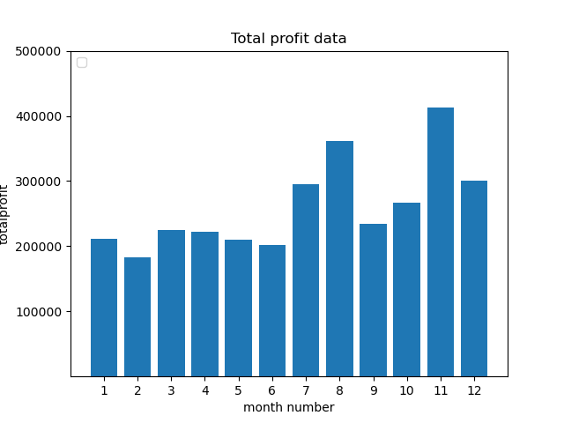

1. Do the scatterplot on Total profit & Month_number column.

import pandas as pd

import matplotlib.pyplot as plt

df = pd.read_csv("C:\\Users\\91778\\Desktop\\python ExcelR\\Assignments\\company_sales.csv")

monthList = df ['month_number'].tolist()

totalprofit =df['total_profit'].tolist()

plt.scatter(monthList,totalprofit)

plt.xlabel('month number')

plt.ylabel('totalprofit')

plt.legend(loc='upper left')

plt.title('Total profit data')

plt.grid(True, linewidth= 1, linestyle="--")

plt.show()

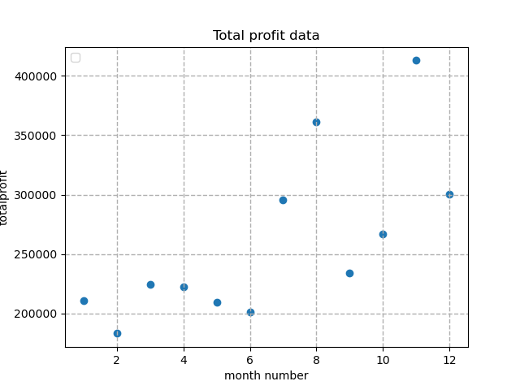

1. Plot the Total profit with format” red square -” (“rs-”) and only “red circles “ (“ro”).
2. Read sales data of bathing soap of all months and show it using a bar chart.

import pandas as pd

import matplotlib.pyplot as plt

df = pd.read_csv("C:\\Users\\91778\\Desktop\\python ExcelR\\Assignments\\company_sales.csv")

monthList = df ['month_number'].tolist()

bathingsoap=df['bathingsoap']

plt.bar(monthList,bathingsoap)

plt.xlabel('monthList')

plt.ylabel('bathingsoap')

plt.legend(loc='upper left')

plt.title('Sales Data of Bathing Soap')

plt.show()

